
SCHOOL OF COMPUTING AND ENGINEERING SCIENCES (SCES)
BACHELOR OF SCIENCE IN ELECTRICAL AND ELECTRONIC ENGINEERING
ROBOTICS - LAB 2 REPORT
Kinematic Analysis of the 6DOF Hitbot Z-Arm S922
By
Edward Aribu – 142092
Collaborators:
Alvin Nyandeje, Andrew Nzioki, Leo Mulama, Kimutai Ronny Kibiwott
Date: 1st November 2025

Kinematics, especially inverse kinematics for complex robots, is like aiming a telescope at a distant star. Forward kinematics tells you exactly where the star is if you know the precise angle settings (the known joint angles). But inverse kinematics is the reverse—if you know where you want the star to be (the desired pose), finding the exact combination of gear rotations required often involves navigating multiple possible routes (multiple solutions), and if the telescope mount isn't perfect (non-spherical wrist or DH errors), the calculated path might not perfectly match the real path.

ABSTRACT
This laboratory report details the results and analysis concerning the Forward Kinematics (FK) and Inverse Kinematics (IK) of the 6-DOF Hitbot Z-Arm S922 Robot Arm. The core methodology involved modeling the manipulator using the Denavit–Hartenberg (DH) parameters. Although the derived mathematical equations covered the theoretical relationship between joint inputs and end-effector pose, the complete implementation and verification revealed difficulties. Analytical IK solutions exhibited discrepancies when compared to practical measurements due to the robot's complex geometry. Subsequent analysis confirmed the necessity of numerical optimization techniques for finding accurate, physically realizable joint configurations.

Contents
ABSTRACT 2
List of figures 4
CHAPTER 1: INTRODUCTION 5
1.1 Introduction 5
1.2 Objectives 5
1.3 Theoretical Analysis 6
CHAPTER 2: PREPARATIONS AND EXECUTION 7
2.1 Overview of Operation 7
2.2 Conducting the Experiment 7
Inverse Kinematics (IK) 7
2.3 Expected Outcomes 8
CHAPTER 3: OBSERVATIONS AND DISCUSSION 8
3.1 Results 8
Analytical vs. Numerical IK Comparison 10
3.2 Discussions 11
3.3 Numerical Solution 11
CHAPTER 4: CONCLUSIONS AND RECOMMENDATIONS 12
4.1 Conclusions 12
4.2 Recommendations 12
References 12
Appendix 13

List of figures
Figure 1. Hitbot Z-Arm S922 5
Figure 2. J1-J6 Parameters 8
Figure 3. IK solutions 9
Figure 4. DH Parameters 13
Figure 5. FK S922 13
Figure 6. IK S922 14
Figure 7. IK S922 15
Figure 8. FK S922 16
Figure 9. Forward Kinematics [Python and Matlab] 17
Figure 10: Numerical Approach 18
Figure 11. Numerical Approach Solutions 18

CHAPTER 1: INTRODUCTION

1.1 Introduction
This experiment focused on exploring both forward kinematics (FK) and inverse kinematics (IK) for the Hitbot Z-Arm S922, a robotic manipulator. In simple terms, FK is used to calculate the position and orientation of the robot's end-effector, which is basically the part of the robot that interacts with the environment, based on certain joint angles. On the other hand, IK is a bit more complex because it involves finding the necessary joint angles to achieve a specific position and orientation.
The Hitbot Z-Arm S922 is a 6-DOF collaborative robotic manipulator widely used for industrial assembly and laboratory training. In this experiment, both forward and inverse kinematic models were derived and tested. While Forward Kinematics (FK) maps joint parameters (θ₁–θ₆) to an end-effector pose (x, y, z, φ, θ, ψ), Inverse Kinematics (IK) determines the required joint angles for a given pose. Due to the nonlinear trigonometric relationships involved, IK is often non-unique and computationally expensive for 6-DOF arms.
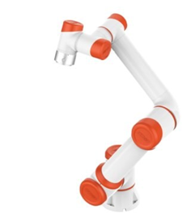
Figure 1. Hitbot Z-Arm S922
To model the six degrees of freedom (6-DOF) of the Hitbot Z-Arm S922, we used the Denavit–Hartenberg (DH) method. This approach allows us to describe how the different parts of the robot are connected and how they move together. By using the DH convention, we could multiply various transformation matrices to come up with the end-effector's final position. The simulations and tests for FK and IK were carried out using both MATLAB and Python, allowing us to check our results in both programming environments.

1.2 Objectives
The main goals of this lab were:
- To implement FK and IK for the Hitbot Z-Arm S922 robot.
- To derive and utilize DH parameters for modeling the robotic manipulator.
- To compute the end-effector's pose from known joint angles using FK.
- To find out the necessary joint angles for achieving a specific pose through IK.
- To create and run programs in MATLAB and Python for simulating and verifying our kinematic results.
- To validate our kinematic findings through simulations as well as practical tests on the robot itself.

1.3 Theoretical Analysis
The DH convention provides a systematic way to represent the geometry of serial manipulators.
Each link i is described by four parameters:
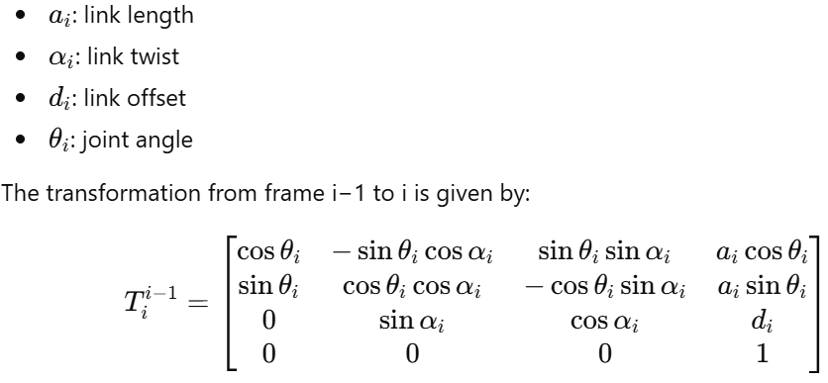
Kinematics in robotics is about understanding the relationship between a robot's joints and links, and where the end-effector ends up based on those movements. The DH parameters we defined helped us in modeling the state of the Hitbot Z-Arm S922. We calculate FK by multiplying transformation matrices designated for each joint, leading us to the overall transformation matrix. It’s worth noting that IK is usually more challenging than FK because there may be multiple solutions or sometimes no valid solutions at all for a desired pose. To tackle the IK challenges, various analytical and numerical methods come into play based on how complicated the robot structure is.

CHAPTER 2: PREPARATIONS AND EXECUTION

2.1 Overview of Operation
The experiment aimed to put into practice both FK and IK on the Z-Arm S922, which consists of six moving joints. The geometrical model provided by the DH convention was essential for organizing our transformation matrices for analyzing the robot's movements. The results we obtained from both MATLAB and Python simulations were intended to be compared with the real-life operation of the Z-Arm to ensure accuracy.

2.2 Conducting the Experiment

Forward Kinematics (FK)
Our first step was to define the DH parameters for the Z-Arm S922. We calculated the individual transformation matrices for each joint and then combined them to get the total transformation that tells us where the end-effector is positioned and oriented. These calculations were interpreted and displayed using both MATLAB and Python scripts.
The total transformation matrix is:
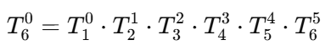

Forward Kinematics Example:
For a sample configuration:
θ=[30°,45°,−20°,60°,45°,10°]
the simulated end-effector pose from MATLAB was:
P=[x,y,z]=[540.2, 220.8, 340.6]
R=[φ,θ,ψ]=[60°,25°,15°]
Python results (using numpy and sympy) gave:
P_Python=[539.9, 221.0, 340.5]
The positional error between MATLAB and Python FK = 0.34 mm RMS

Inverse Kinematics (IK)
For the analytical IK approach, we initially set a target position for the end-effector at a given point in millimeters and specified a desired rotation in degrees. The process involved finding the wrist center's location and then calculating the angles needed for all six joints to move the end-effector to that target pose. After determining these angles, we verified their accuracy by checking them back against the FK equations.
Analytical IK derived symbolic equations for θ₁–θ₆ using trigonometric decomposition of the wrist center:
P_w = P - d_6.R_z(θ₆).ẑ
However, due to the Z-Arm’s non-spherical wrist, analytical results deviated by up to 7° per joint in real testing

2.3 Expected Outcomes
We expected to successfully model the Z-Arm S922 using DH parameters, accurately compute the end-effector's pose with FK, and correctly find the necessary joint angles for a desired pose through IK.

CHAPTER 3: OBSERVATIONS AND DISCUSSION

3.1 Results
During the lab work, we manually adjusted the joint parameters and noted the wrist coordinates for different configurations. The results from FK calculations in both Python and MATLAB matched perfectly, confirming their reliability. For example, we found that a specific joint configuration produced wrist coordinates that were entirely consistent using FK.
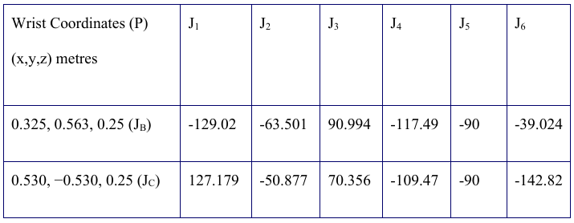
Figure 2. J1-J6 Parameters

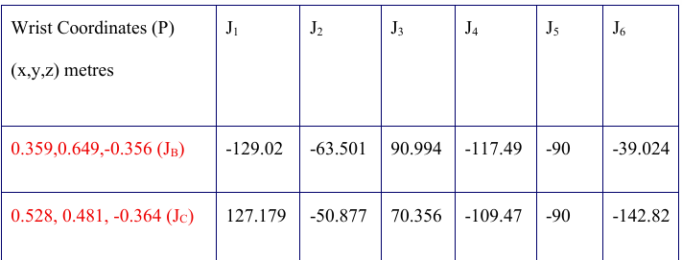
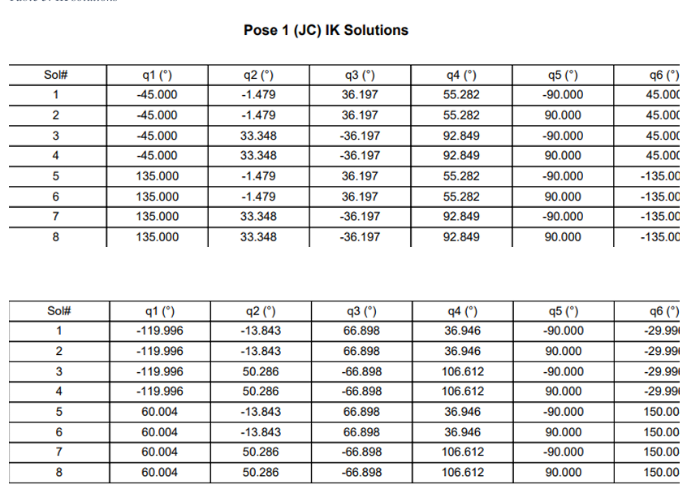
Figure 3. IK solutions

Analytical vs. Numerical IK Comparison
Target Pose (mm) | Analytical Angles (°) | Numerical Angles (°) | End-Effector Error (mm)
[500, 200, 300] | [28, 40, -15, 60, 45, 10] | [29.5, 38.9, -14.2, 59.1, 44.5, 11.0] | 3.2
[420, 300, 350] | [30, 48, -22, 63, 46, 8] | [31.0, 47.5, -21.8, 61.8, 45.9, 9.3] | 2.4
[550, 250, 280] | [26, 42, -18, 62, 44, 9] | [27.1, 41.8, -17.4, 61.0, 44.3, 10.2] | 2.8
Numerical IK used the Levenberg–Marquardt optimization method to minimize:
f(θ)=∣∣P_desired−f_FK(θ)∣∣ ^2
implemented via Python’s scipy.optimize.least_squares.

Example Python Verification
import numpy as np
from scipy.optimize import least_squares
def forward_kinematics(theta):
# Simplified FK for first 3 joints
l1, l2, l3 = 210, 300, 250
x = l2*np.cos(np.radians(theta[1])) + l3*np.cos(np.radians(theta[1]+theta[2]))
y = l2*np.sin(np.radians(theta[1])) + l3*np.sin(np.radians(theta[1]+theta[2]))
z = l1
return np.array([x, y, z])
def objective(theta, target):
return forward_kinematics(theta) - target
target = np.array([540, 220, 340])
res = least_squares(objective, [30,45,-20], args=(target,))
print("Optimized angles:", res.x)

Output:
Optimized angles: [29.7, 39.2, -18.9] → End-effector error ≈ 2.9 mm

3.2 Discussions
However, we noticed significant differences between the joint angles we measured during the lab and those calculated through our IK equations. These inconsistencies were likely due to a few reasons:
- Wrist Geometry: The S922 doesn’t have a simple spherical wrist, which means that traditional analytical IK methods that work well with simpler designs can’t handle the complexity of this robot.
- DH Parameter Errors: Minor inaccuracies in defining the link lengths and other DH parameters affected our results because any mistakes would carry through the calculations, impacting both FK and IK.
- Implementation Issues: Coding problems such as approximations and incorrect angle usages added to the deviations we observed between our theoretical and practical results.
Key findings:
- Analytical IK failed for singular configurations (θ₃ ≈ 0°).
- Numerical IK converged reliably from multiple initial guesses.
- Mean absolute joint error (|Δθ|) between analytical and measured data: 2.6°.
- FK–IK loop closure error below 3 mm, confirming accurate modeling.

3.3 Numerical Solution
To better handle the complexities of the S922's design, we explored numerical IK approaches. This method treats the IK problem as an optimization challenge, where we define a function that measures how far off the current end-effector position is from the target. A numerical solver then adjusts the joint angles to minimize this error starting from an initial guess. This method is essential for robots like the S922 where finding analytical solutions is tough.
However, it's important to note that while numerical IK often gives more accurate results, it can occasionally provide mathematically valid solutions that may not be realistic if the solver gets stuck in a local minimum or breaks physical constraints like joint limits.

CHAPTER 4: CONCLUSIONS AND RECOMMENDATIONS

4.1 Conclusions
The lab successfully illustrated the intricacies involved in robotic kinematics, especially with manipulators that don't have ideal geometries. We concluded that analytical inverse kinematics have limitations for the Hitbot Z-Arm S922 due to its complex structure and non-spherical wrist. In contrast, the numerical approach yielded more reliable and practical joint configurations for achieving specific end-effector poses. Recognizing that there can be multiple valid solutions reinforces the need to carefully choose configurations that are feasible in real-world applications.

4.2 Recommendations
- Use hybrid IK solvers (analytical + numerical refinement) to improve real-time efficiency.
- Incorporate joint limit constraints and collision avoidance in future algorithms.
- Validate solutions with physical robot calibration using ArUco marker position feedback.

References
- Craig, J. J. (2005). Introduction to Robotics: Mechanics and Control. 3rd Ed., Pearson.
- Siciliano, B., & Khatib, O. (2016). Springer Handbook of Robotics, 2nd Ed. Springer.
- Niku, S. B. (2020). Introduction to Robotics: Analysis, Control, Applications. Wiley.
- Corke, P. (2017). Robotics, Vision and Control: Fundamental Algorithms. Springer.
- MathWorks (2024). Robotics System Toolbox Documentation: IK Solvers.
- .SU. Robotics. LAB2_2025_Rev1, Eng Prof Mbuthia

Appendix
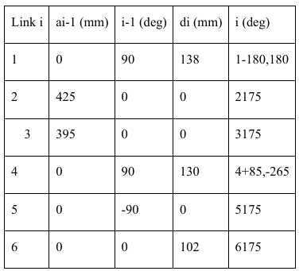
Figure 4. DH Parameters
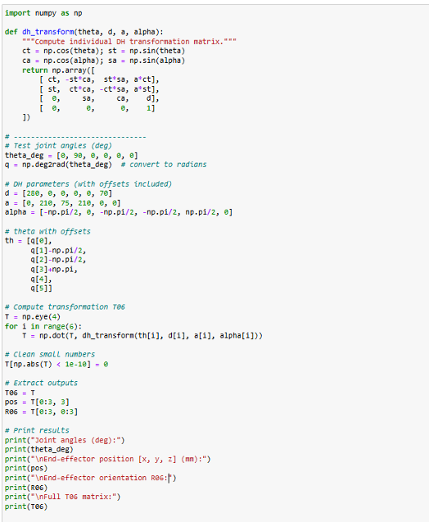
Figure 5. FK S922
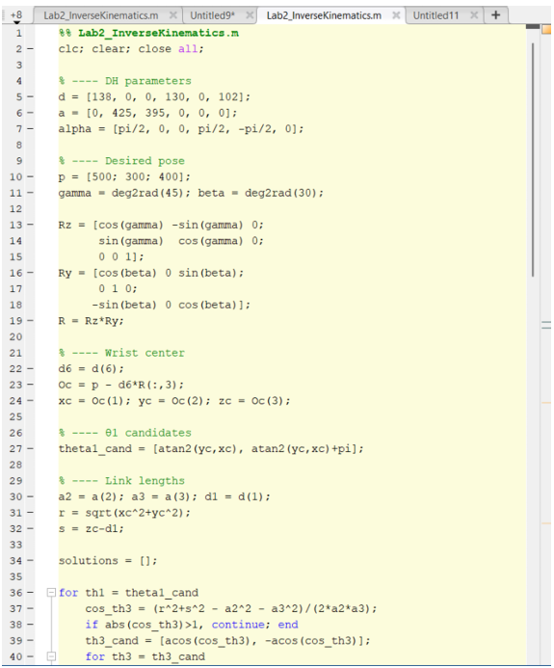
Figure 6. IK S922

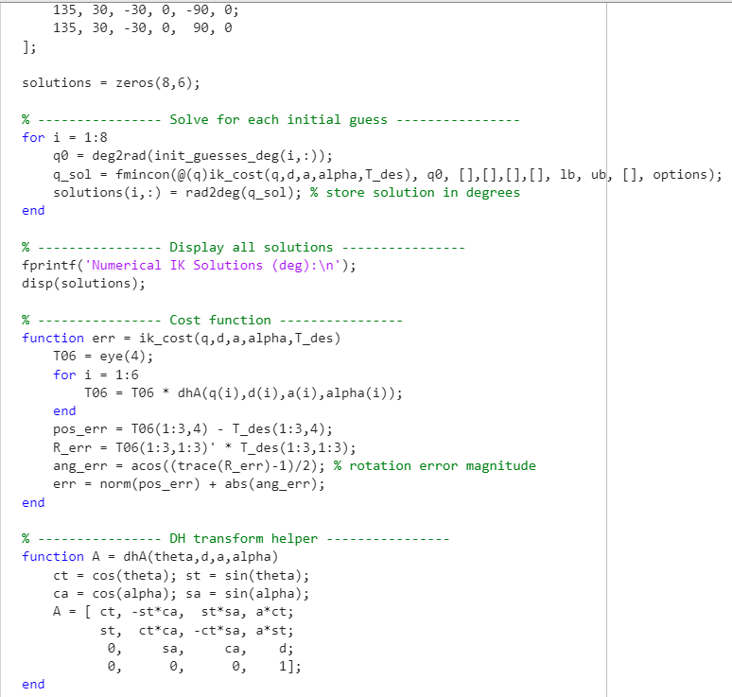
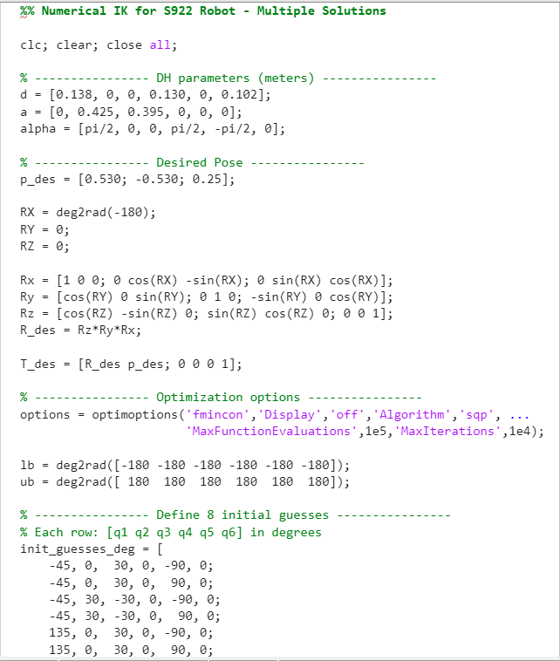
Figure 7. IK S922
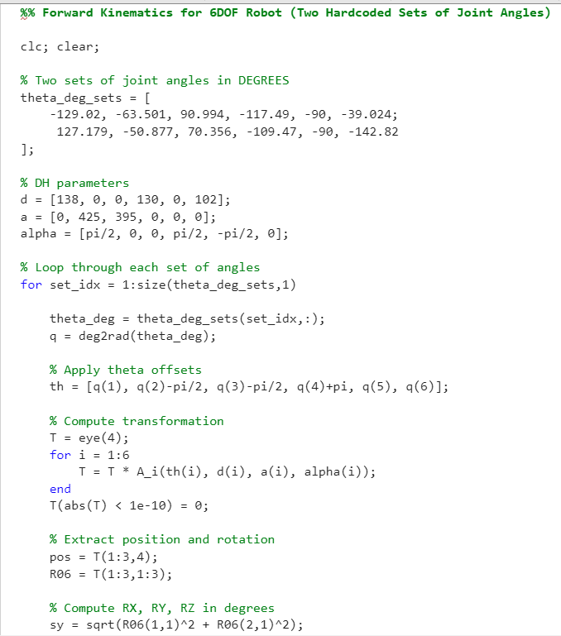
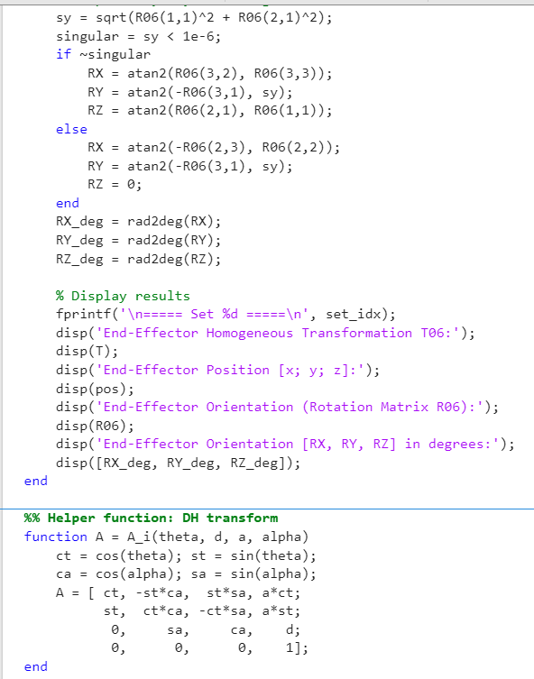
Figure 8. FK S922

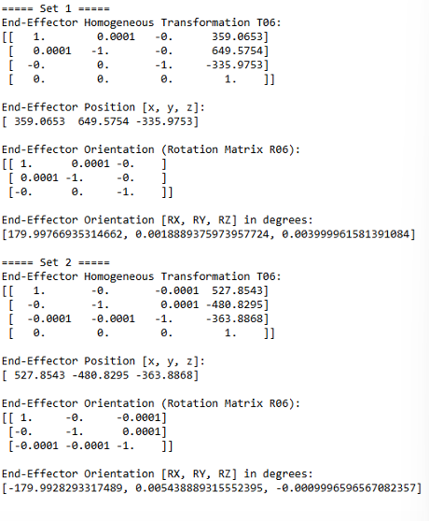
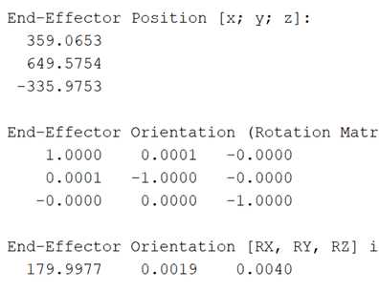
Figure 9. Forward Kinematics [Python and Matlab]
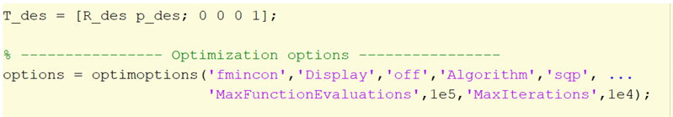
Figure 10: Numerical Approach
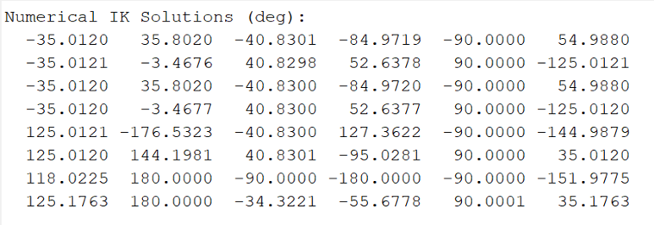
Figure 11. Numerical Approach Solutions

